# Project Proposal



***Patent Pending

## Description

A social media application that allows users to share music from various sources and interact with their social network by “liking” and “commenting” on posts. This can be a centralized application for sharing and expressing musical interests with your friends/followers!

Too often I find myself searching through deepest, darkest caverns of Spotify playlists and followers of followers to find new and interesting music, why not have an app for that? This app proposes a solution to the vast abyss of music out on the internet consolidating it into a singular application.

# Screens

The application will have numerous screens that allow a user to share music and interact with other users.

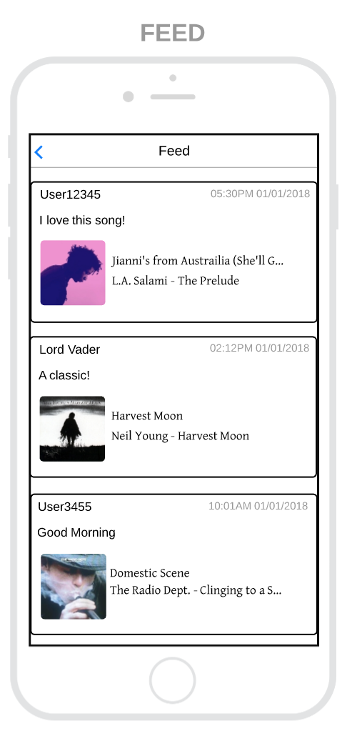

## A Feed

The feed should be a generic stream of user content where a user can view chronological posts made by their followers. This feed will include the ability “like” and “comment” on a post and possibly “save” a post if the user liked the song that was shared. Posts should have “playable” media so users can click on a post and the shared song should begin to play.

## 

## Create Post

There should also be a screen to “create a post” which involves adding a song via Youtube, Spotify, Soundcloud, Apple Music, or other mediums with adoptable API’s. A user may wish to write a short blurb about the song “Been really enjoying this artist lately” which will be displayed in the post as well.

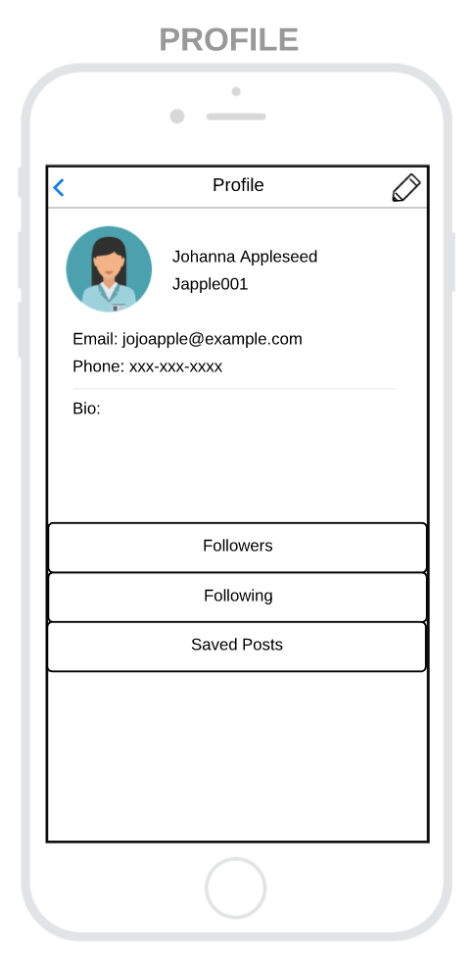

## Profile View

There should be a “view-profile” option, where a user can view and edit their public information, view their social network, view saved posts, etc.

## More Screens

* Edit Profile information
* Comment on post
* (Discover) Page
* Create/Share Playlist?
* View a different user’s profile
* Messaging?
* Many more!

# Target Users

This application is a simple, easy to user social network for any and all music lovers. There is no target demographic other than the appreciators of music! I think with a mobile and web facing application, there are very few limits to whom this application can accommodate.